**Story Telling Project**

# Overview

The goal of this capstone project is to create a web application using Streamlit that enables users to translate text into different languages, convert the translated text to speech, and download the audio file. The project leverages OpenAI's GPT-3.5-turbo model for translation and Google Text-to-Speech (gTTS) for speech synthesis.

# Project Description:

This project aims to develop a system that translates text into various languages and converts the translated text into speech. The system is designed to be user-friendly and interactive, allowing users to either enter text directly or upload a file in various formats (PDF, TXT, Excel, CSV). The text is then translated into a language selected by the user from a dropdown menu.

# Poject Features

1. Language Transaltion : OpenAI's GPT-3.5-turbo for language

translation. Understand input prompts and usage.

2. Add Text-to-Speech: Implemented text-to-speech functionality using gTTS and save the

audio file.

3. Design User Interface: Streamlit used for user interface.

4. Implement Language Translation: Write code to take user input, select a language, and use

GPT-3.5-turbo for translation.

5.Prompt Engineering: Used prompt to translate the text

6. Incorporate File Upload: Users can upload text or PDF files for translation.

7. Enhance User Experience: Implement error handling, user-friendly messages, and

instructions.

# How to use the application

The application has an user interface with fiel selecting option to

## a)Home Page

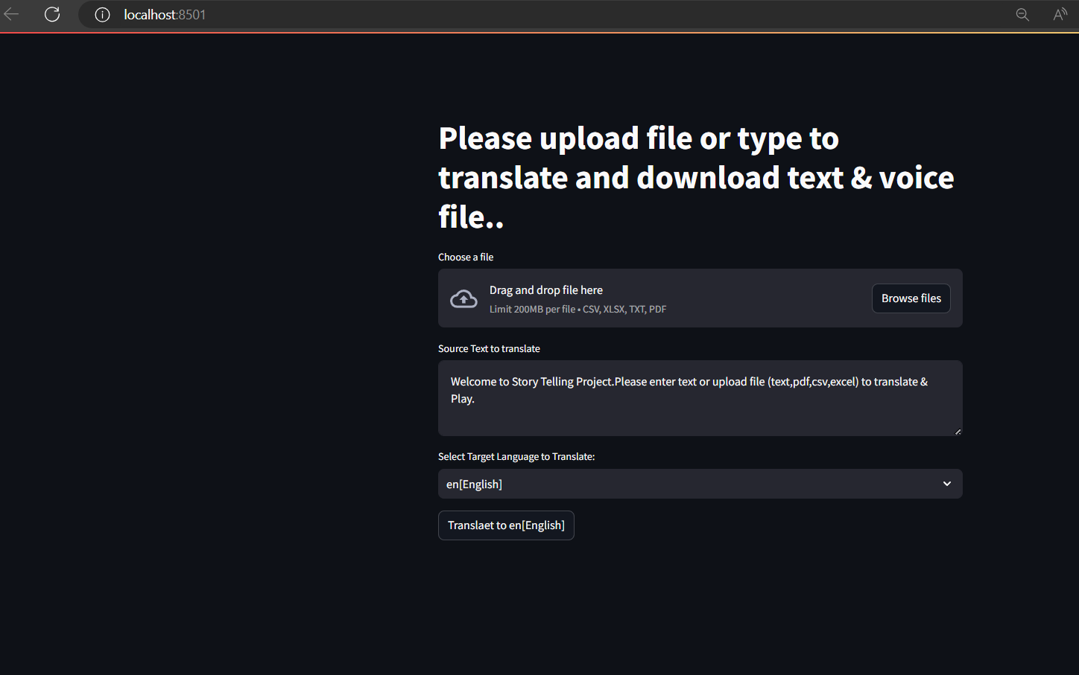

This application has ahome page where user can upload files of type text ,csv,pdf,excel and he has the option to enter text.Aftre either upload file or directly enter the text he can select the target language to translate from te combo provided.The user need to click the ‚Translate to {Traget language}‘ button.Then the text will be translate using OpenAi -GPT-3.5-turbo & prompt to tralslate text and saved in a file with the target language name.Also using

“e gTTS library for text-to-speech“ te translated content can be converted to an audio file with target lanuage name.

Also user acn upload csv,pdf and excel and translate.

## b)Source Text Area:

This Text area user have te option to enter text.

## c) Target Language Selection DropDown:

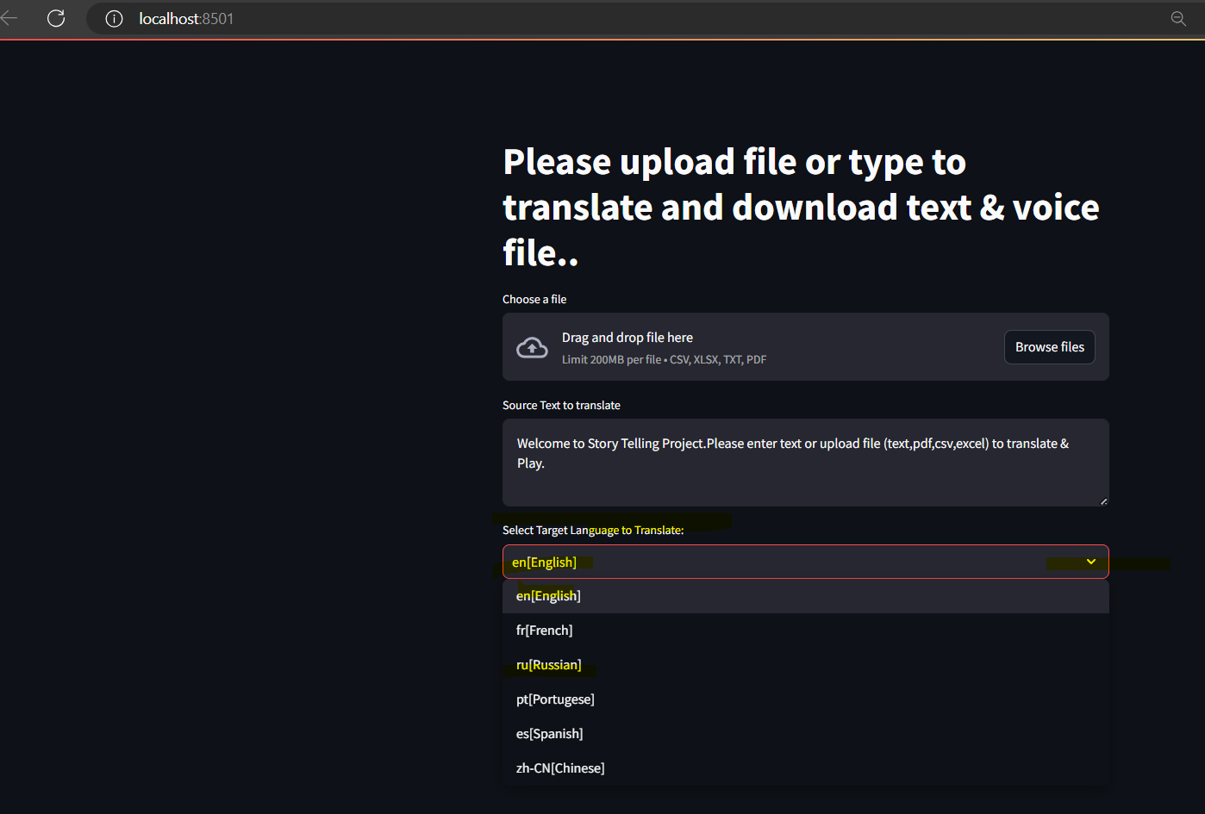

User can select the target language to translate using this dropdown

## d)Translate button

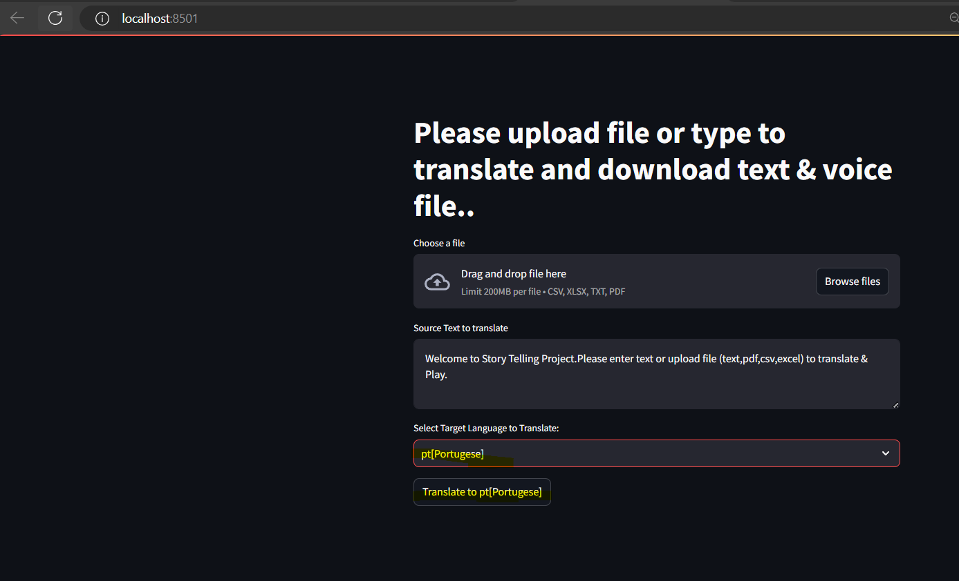

Based on the target language selection user can see the translate button text get updated and can click to do initiate the translation in back ground to save translated text & audio.

## e)Browse File option

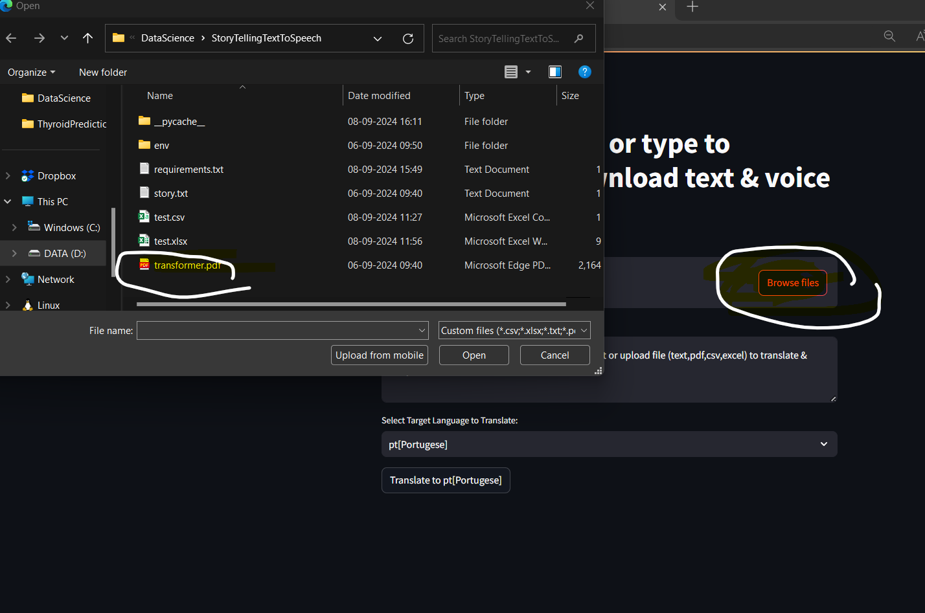

User can browse and select te files to translate

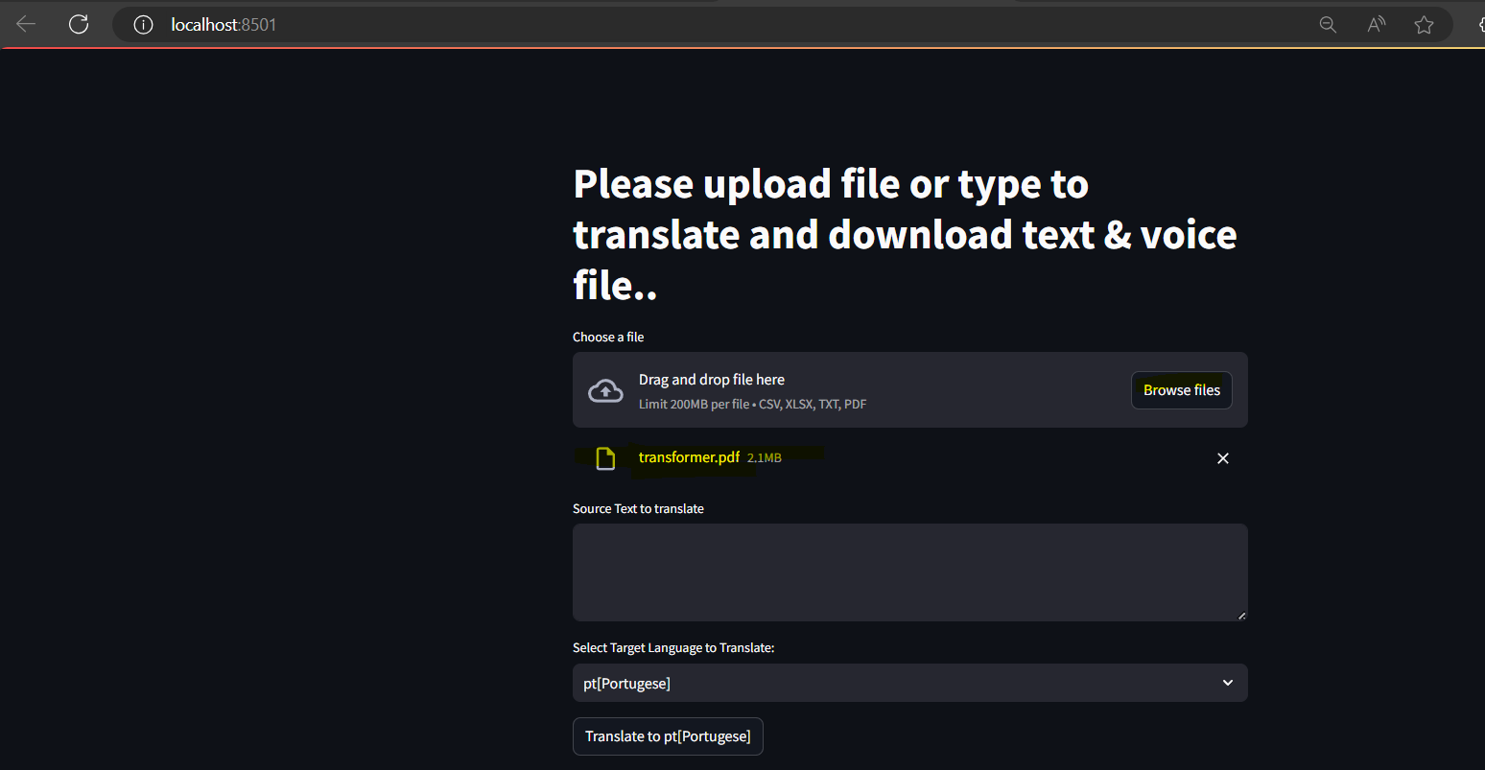

Uploaded fiel can be displayed in UI.

## f)Translate user entry text

User entered a text in text area and selected portugese language for translation & clicked translate button.

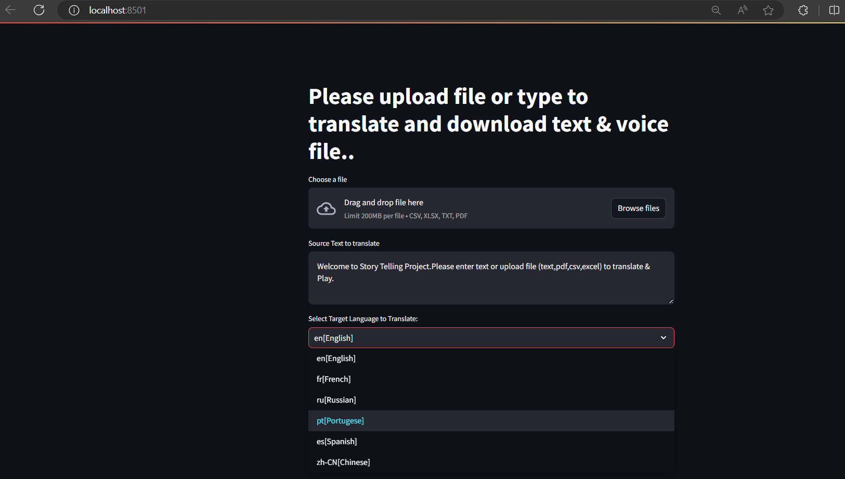

Running in back ground

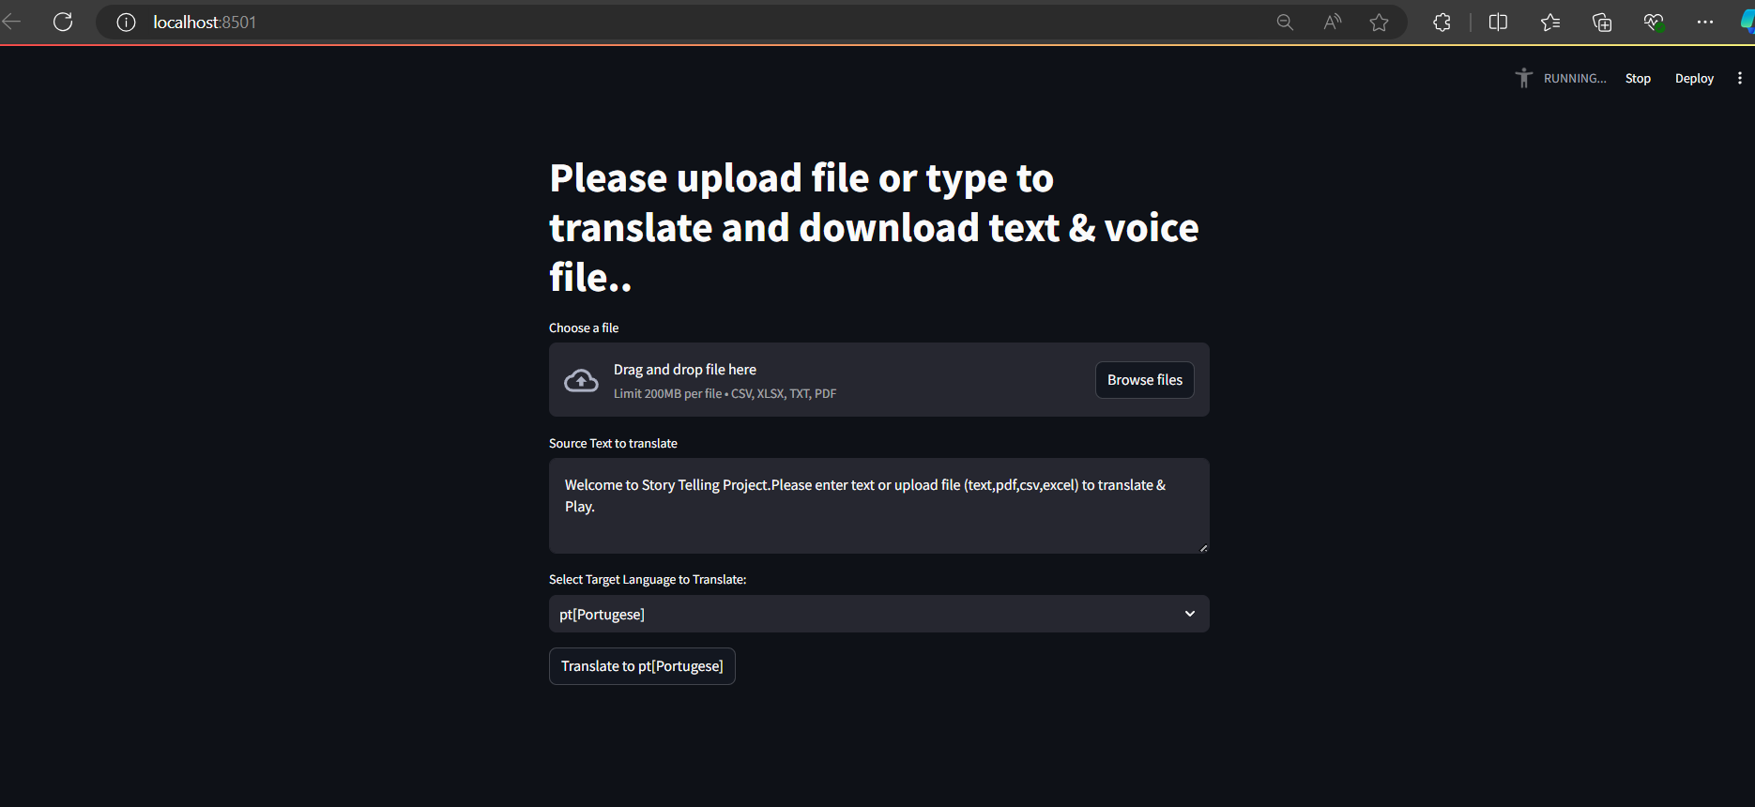

User can see the portugese translated text

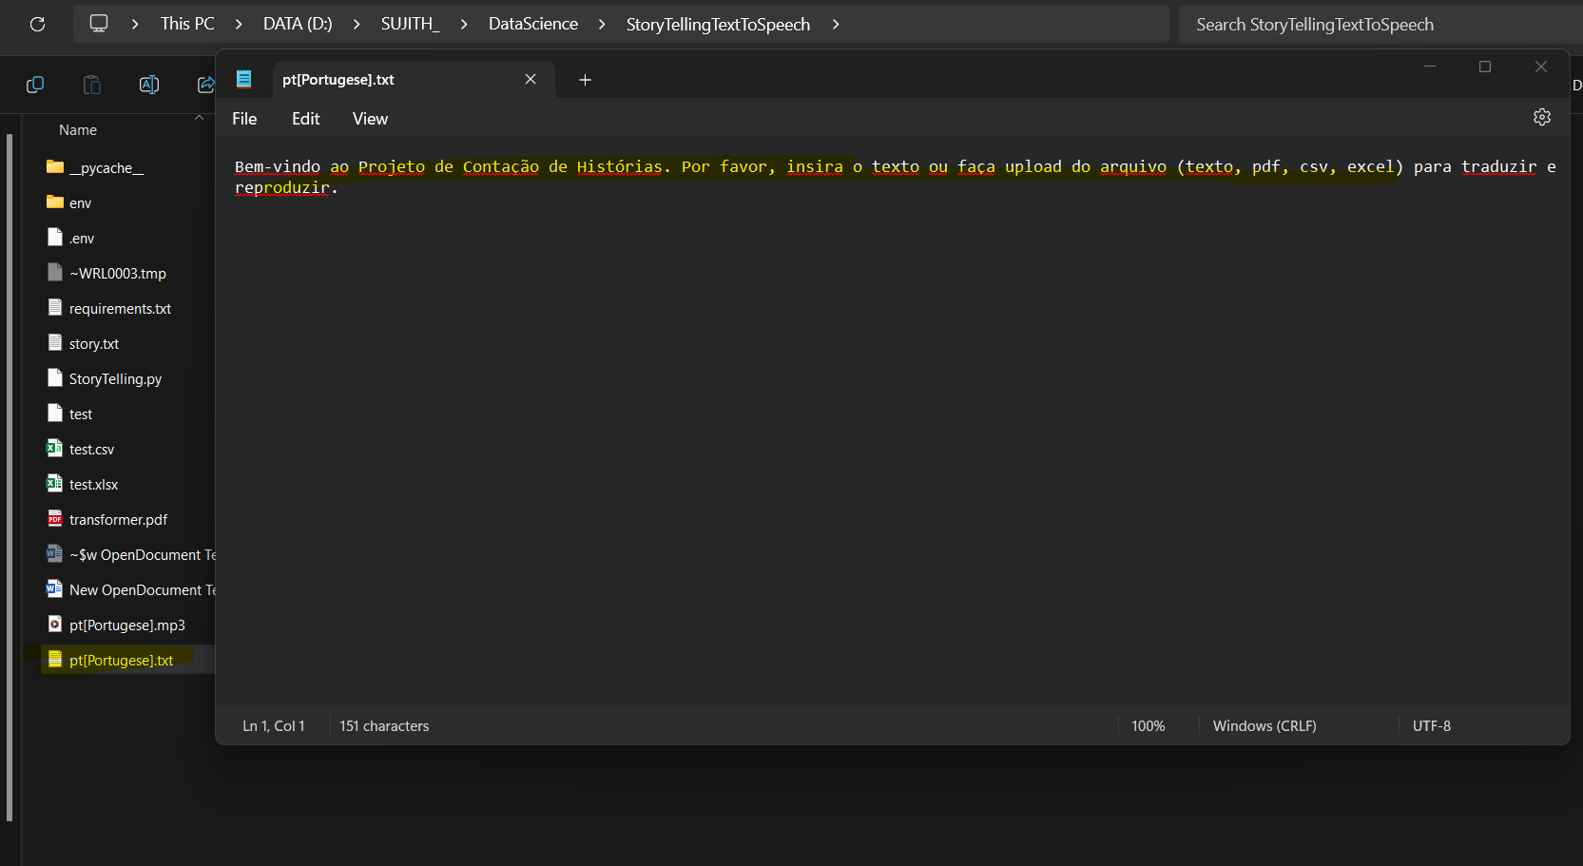



User can see the portugese translated audio file and he can play and hear translated voice.



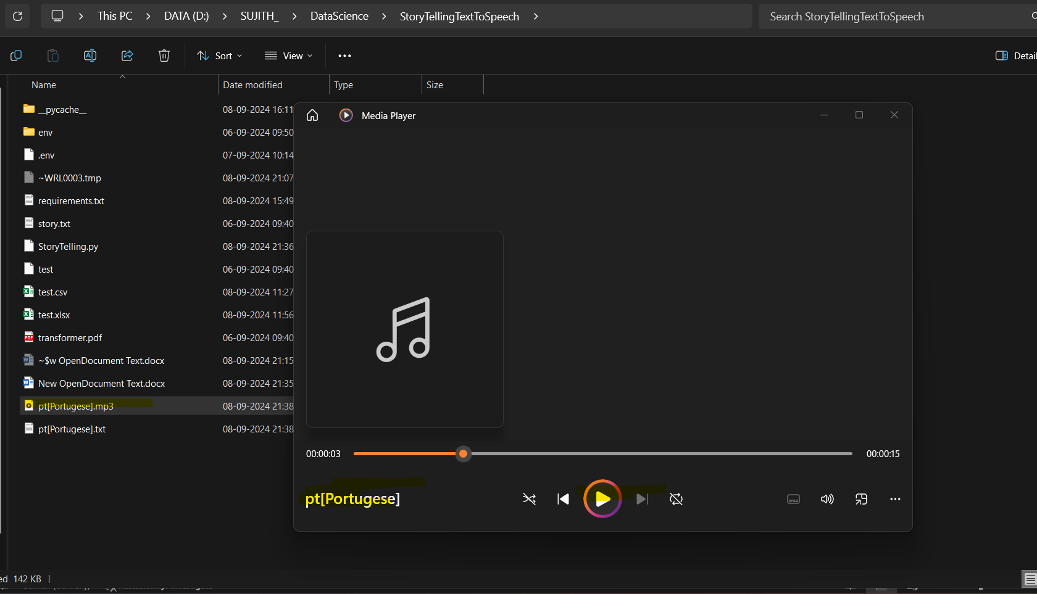

## g)Translate an uploaded file

The story file

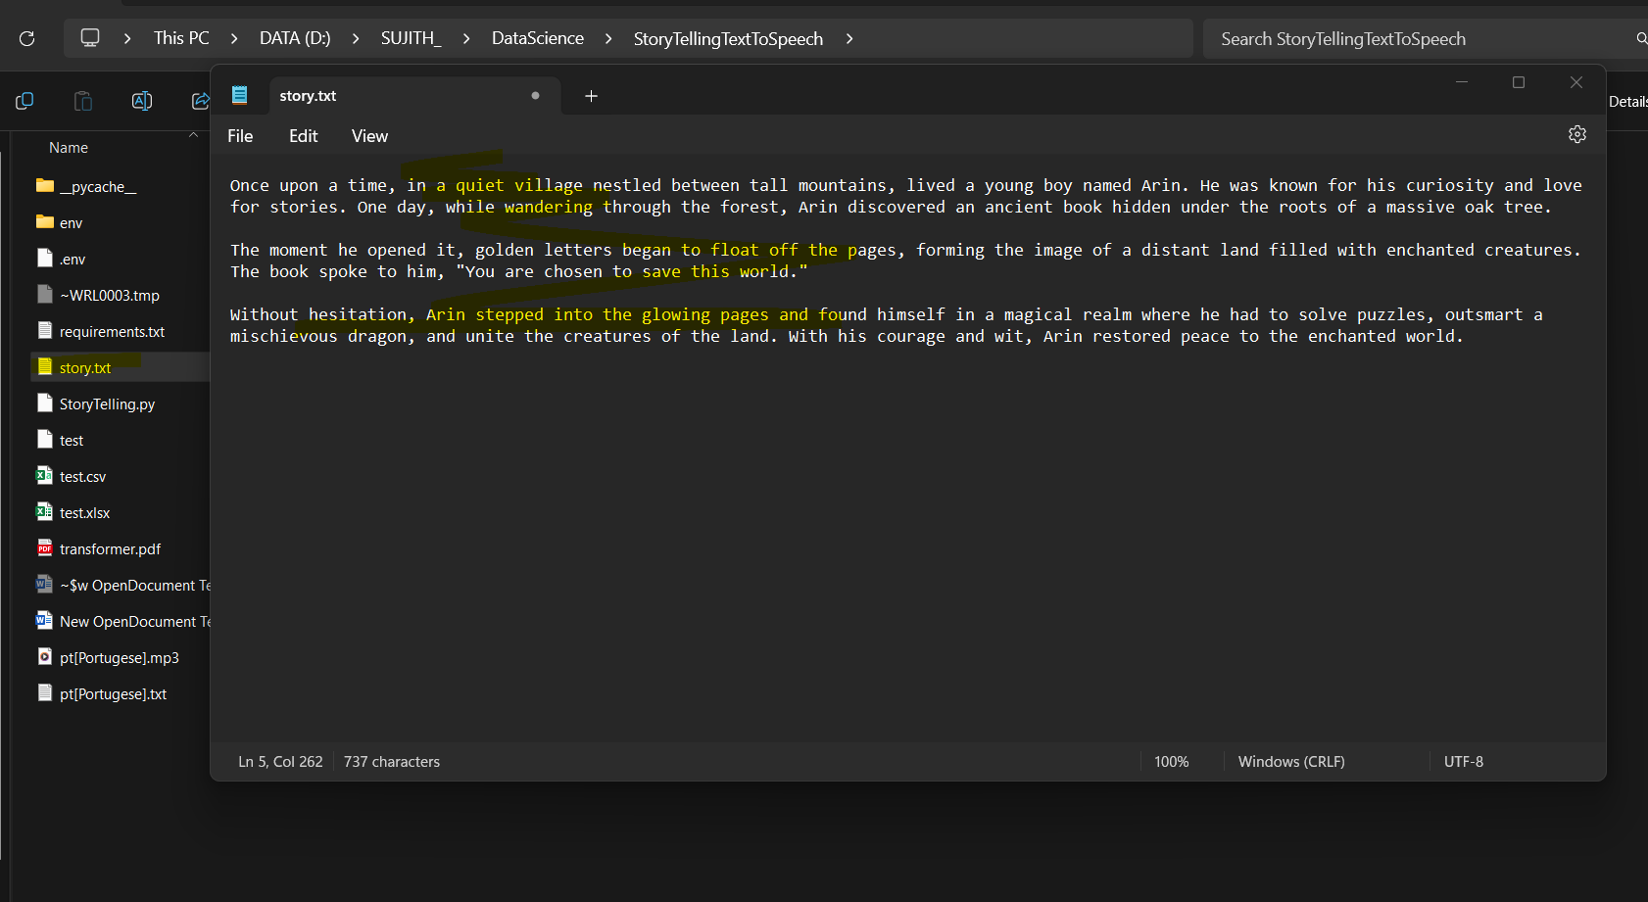

Uploading from UI

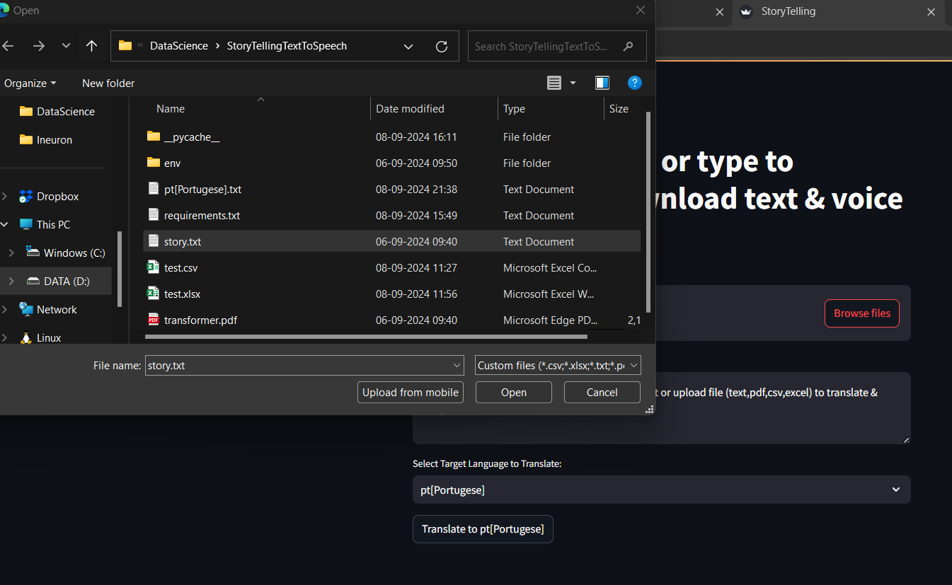

Translating to Russian

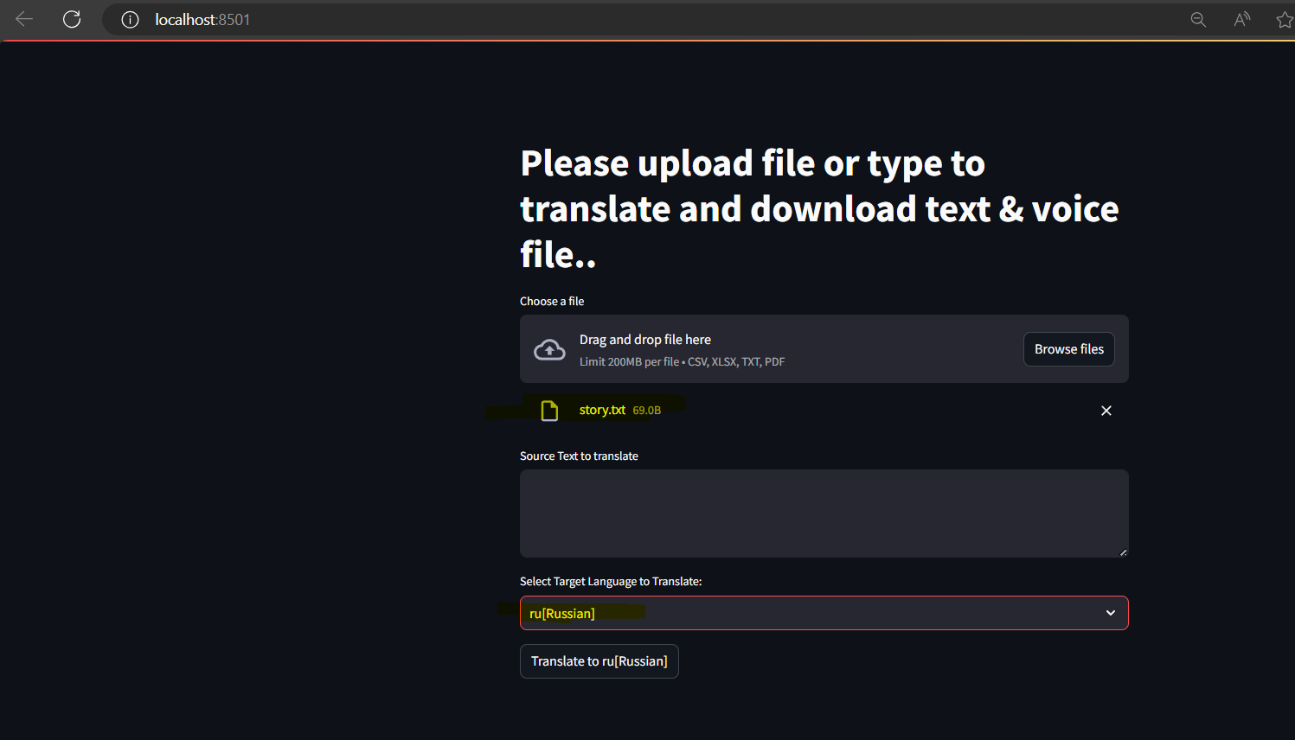

User can see translated text



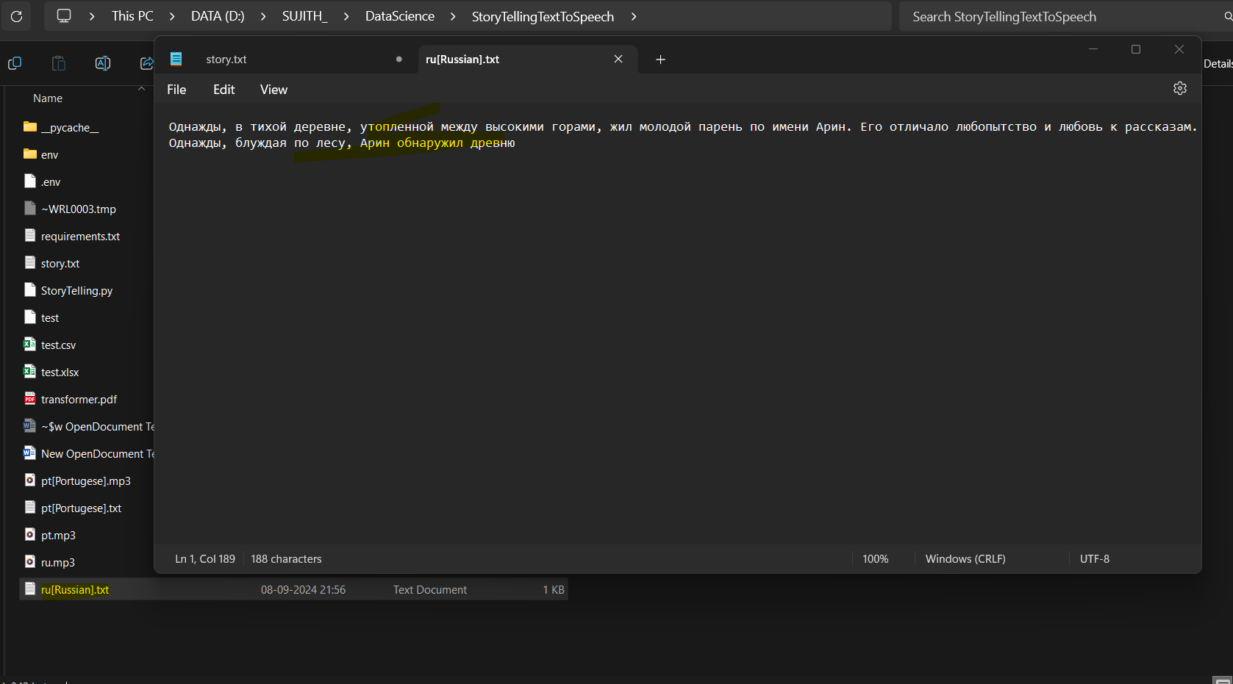

User can see translated russian audio

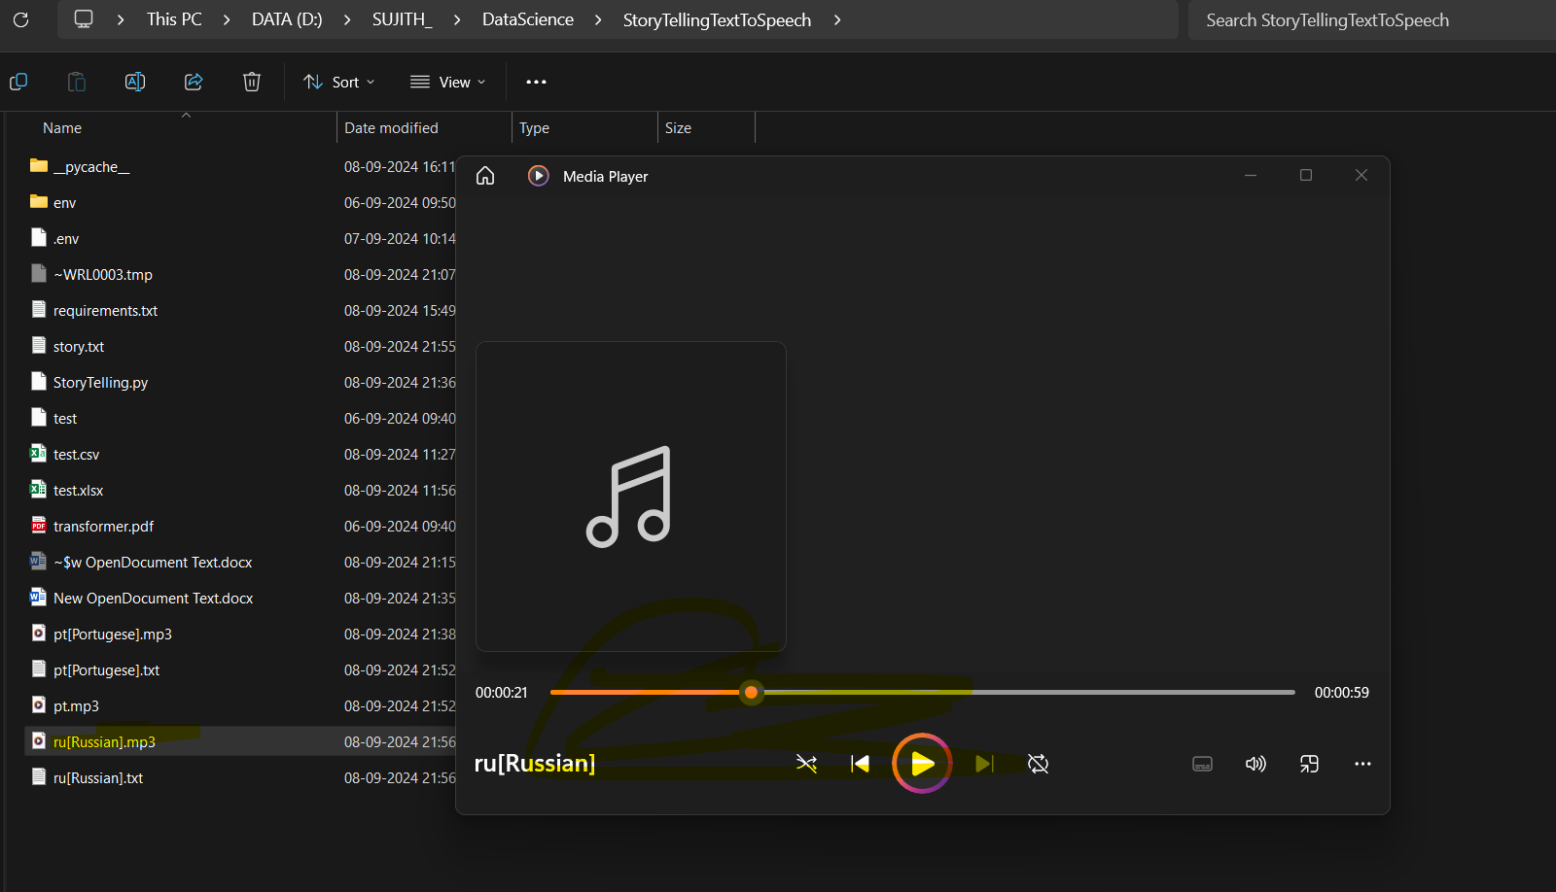

# Challenges

* Streamlit eventhandling
* Reading files csv excel
* Installation related error

# Consideration

* Analysing improvements in UI and functionality of this application
* More error handling